INTERSCAN

ENGINEERS AUSTRALIA
CEREMONY REPORT
INTERSCAN
Microwave Landing System
Heritage Recognition Ceremony
Airways Museum, Wirraway Road, Essendon Airport, Melbourne, Victoria
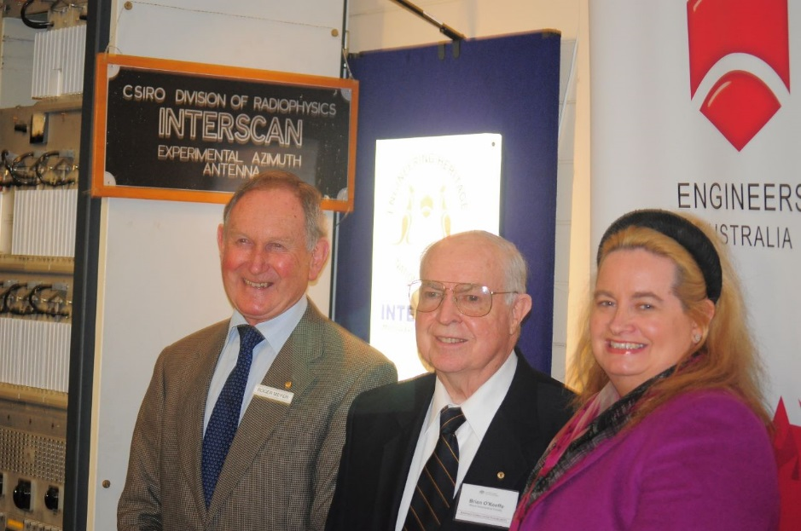

Date of ceremony: 9 November 2013

Microwave Landing system

Cover Photograph:

VIP’s in front of the interpretation following the unveiling. From left: Roger Meyer OAM, President, Civil Aviation Historical Society and representative of the Airways Museum; Professor Brian O’Keefe AO, previously of the Department of Civil Aviation and closely involved with the development of INTERSCAN; Councillor Madeleine McManus, National Councillor, Engineers Australia.

Image: Owen Peake

CONTENTS
PAGE
1 Introduction 4

2 Invitations 4

3 Distinguished Guests and Apologies 4

4 Program and Running Sheet 4

5 Speech Notes 5

6 Ceremony Handout 5

7 Media Release 5

8 Media Articles 5

9 Letters of Thanks 5

10 Costing 6

11 Allocation of Tasks 6

12 Interpretation Panel 7

13 Photographs 8

Attachment 1 - Invitation Letter 10
Attachment 2 - Advertising Flyer 11
Attachment 3 - Running Sheet 12
Attachment 4 - Speech Notes – Johnathon Schembri 15
Attachment 5 - Handout Document 17
Attachment 6 – Media Release 25
Attachment 7 – EHA Magazine Article 26
Attachment 8 - EA Magazine Article 28
Attachment 9 - EV Newsletter Article 30
Attachment 10 - Body of typical thank you letter 32

1 Introduction:

The ceremony for the marking of the INTERSCAN Microwave Landing System with an ENGINEERING HERITAGE NATIONAL LANDMARK was conducted at on 9 November 2013 at the Airways Museum, Essendon Airport at 10:00 am.

Attendance: 63

2 Invitations:

There were two forms of invitation:

2.1 Written invitation sent by mail to 109 people listed by Engineering Heritage Victoria. This list consisted primarily of local dignitaries, council representatives, politicians, heritage industry figures and other stakeholders (copy at Attachment 1).

2.2 Email invitations (see copy of flyer at Attachment 2) sent to the following address lists:

- Engineering Heritage Victoria list (approx 300 on list)
- Victoria Division Board of Engineering members (approx 40 on list)
- Engineering Heritage Australia Member and Corresponding Members (45 on list)

Hence the total number of invitations issues was about 494. With at total attendance of 63 at the ceremony the response rate is approximately 12.75%.

3. Distinguished Guests and Apologies:

Listed on the Running Sheet. See Attachment 3.

4 Program & Running Sheet:

The Running Sheet (Attachment 3) shows:

- Those who spoke at the event and timing
- Distinguished Guests who were acknowledged
- Apologies received who were acknowledged

The Master of Ceremonies was Phil Vabre, Vice President, Civil Aviation Historical Society.

5 Speech Notes:

Speech Notes are attached as follows:

- Johnathon Schembri, Victoria University student involved in writing the nomination for the site (see Attachment 4).

6 Ceremony Handout:

A 12 page A5 ceremony handout was prepared and handed out to all those who attended the ceremony. A copy is at Attachment 5. The handout was based largely on the material from the Interpretation Panels. 100 copies were printed.

7 Media Release:

Engineers Australia issued a Media Release for the event. A copy is at Attachment 6.

8 Media Articles:

8.1 ARTICLE FOR ENGINEERING HERITAGE AUSTRALIA NEWSLETTER

Article written by Owen Peake is at Attachment 7.

8.2 ARTICLE FOR ENGINEERS AUSTRALIA MAGAZINE

Article written by Owen Peake is at Attachment 8.

8.3 ARTICLE FOR EV NEWSLETTER

Article written by Owen Peake is at Attachment 9.

9 Letters of Thanks:

Letters on EA Victoria Division letterhead were sent out over Division President John McIntosh’s signature to the following:

- Adjunct Professor F H B (Brian) O’Keeffe AO
- Roger Meyer OAM
- Phil Vabre
- Carla Cher
- Madeleine McManus
- Geoffrey Boyd
- Dennis Cooper
- Johnathon Schembri
- Anthony Slattery
- Jennifer Darin

A typical draft letter for the above is at Attachment 10.

Costing

Costs of the project were incurred as per the following table:

10

Item No. | Description | Funding Source | Amount
1 | Interpretation Panel Manufacture - Advanced Group – vinyl–on-aluminium for indoor installation | EHV Budget | $355.00
2 | Graphic Design of Interpretation Panel - Richard Venus | EHA Budget (through National Office) | $400.00
3 | Printing of 4 copies of nomination document refund to Owen Peake as per attached claim document to EA | EHV Budget | $100.00
4 | Hire of PA system by EA Victoria Office | EHV Budget | $104.00
5 | Printing of Handout documents (100 off) by EA Victoria Office | EHV Budget | $400.00 (estimate)
6 | Provision of morning tea supplies including slices from Bakery | Aviation Museum | In kind
7 | Provision of 300mm diameter EHA marker from EA National Office | EHA Budget (through National Office) | $300 (estimate)
 |  | TOTAL | $1659.00

11 Allocation of Tasks

A schedule showing the Allocation of Tasks between the various stakeholders was used. This document ensured that all details of organisation were attended to and served as a check list in the run-up to the event.

The tasks of planning of the ceremony were primarily shared between Jessica Bradley in the Victoria Division EA office, Owen Peake, EHV volunteer and Roger Meyer at the Airways Museum.

12 Interpretation Panel:

A mini panel was used in this case as it was embedded in an existing display of INTERSCAN within the museum. The panel was approximately 350 mm wide and 900 mm high. The panel is mounted with simple aluminium “U’ shaped brackets fabricated by Owen Peake. The panel incorporates a full size representation of the National Marker.

A copy of the panel is below:

13 Photographs:
284mm x 208mm
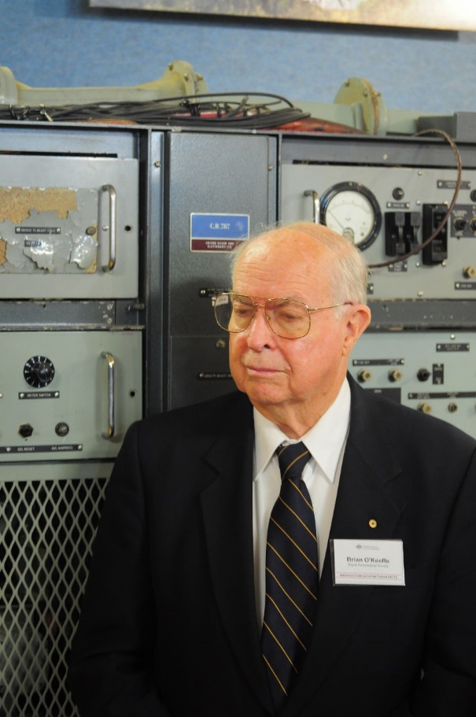

Professor Brian O’Keefe AO, previously with the Department of Civil Aviation.
Image: Owen Peake

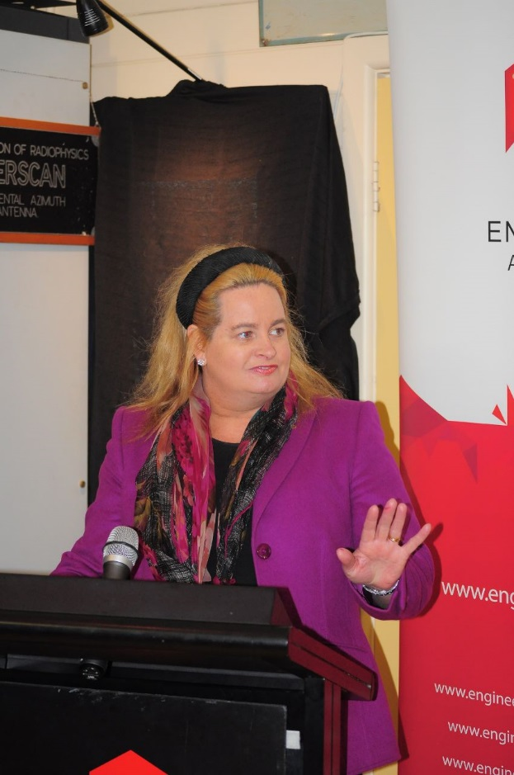

Councillor Madeleine McManus, National councillor of engineers Australia.
Image: Owen Peake
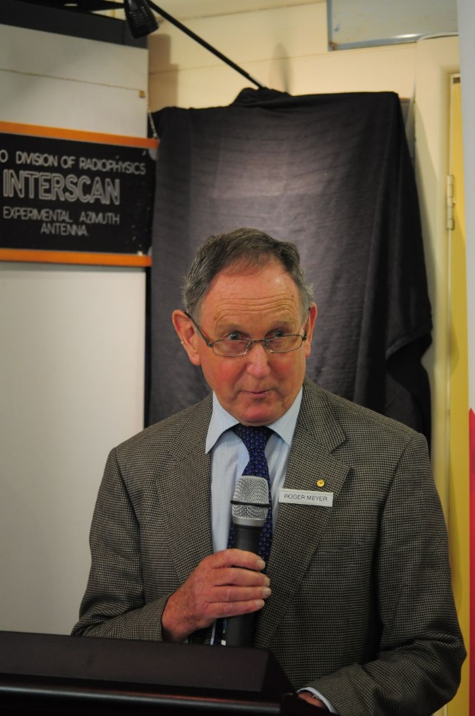

Roger Meyer OAM, President, Civil Aviation Historical Society
Image: Owen Peake

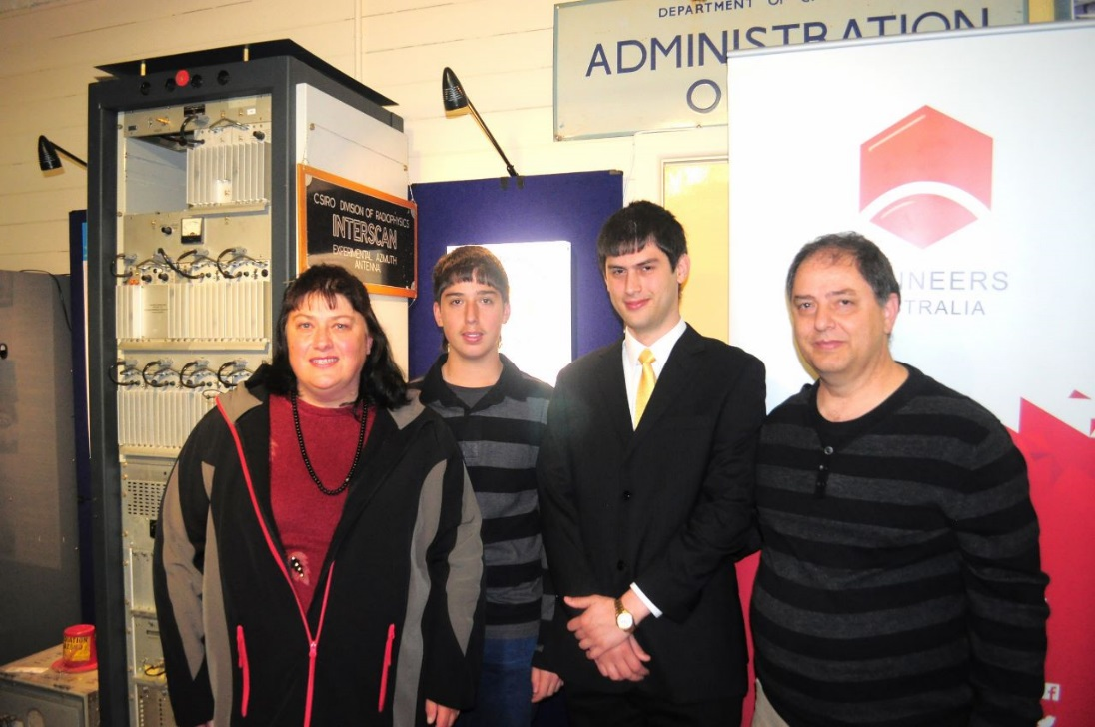

The Schembri Family. Johnathon Schembri who was one of the two students
who wrote the INTERSCAN nomination is third from the left.
Image: Owen Peake

Attachment 1 - Invitation Letter

Attachment 2 - Advertising Flyer

Attachment 3 - Running Sheet

CONTACT LIST

Engineers Australia Key Staff
Glenda Graham Executive Director 0434 070 688
Jessica Bradley Marketing & Events Coordinator 0433 651 475

Key Stakeholders
John McIntosh Division President 0418 128 121
Madeleine McManus National Councillor 0400 044 512
Professor Brian O’Keeffe previously of the Department
of Civil Aviation 0408 487 763

EHV Member
Owen Peake Chair, EHV 0402 933 328

Event sponsor
Roger Meyer Airways Museum
Phil Vabre Airways Museum 0409 873 183

KEY EVENT INFORMATION

Topic: INTERSCAN Engineering Heritage Recognition Ceremony
Date: Saturday 9 November 2013
Time: 10:00 am to 10:35 am
Venue: Airways Museum, Essendon Airport
[The venue will be inside the Airways Museum adjacent to the INTERSCAN exhibit]

RUN SHEET

Time | Action | Responsible
9:00am–9:45am | Set Up Site – banners, chairs (reservations), speakers, lectern, booklets | Jess/Owen
9:45am–10:00am | Guests arrive  Greet Guests/Hand out booklets | Jess/Owen and other volunteers
10:00am–10:05am | Speeches to commence  Welcome by Master of Ceremonies (MC) Phil Vabre, Vice President, Civil Aviation Historical Society  - Welcome to the Airways Museum.  - Briefing on Fire Exits.  - Acknowledgment of Country: “I would like to acknowledge the traditional custodians of the land on which we are meeting as being part of the Kulin Nation”.  - Acknowledgment of Distinguished Guests and Apologies (see next page for details). | Phil Vabre
10:05am–10:11am | Councillor Madeleine McManus, National Councillor, Engineers Australia | Madeleine McManus
10:11am–10:17am | Professor Brian O’Keeffe AO, previously of the Department of Civil Aviation | Prof O’Keefe
10:17am–10:23am | Roger Meyer OAM, Airways Museum | Roger Meyer
10:23 - 10:27am | Johnathon Schembri, Victoria University Student who was one of the two students who wrote the nomination for this site.  Speech Topic: The experience of writing the nomination for INTERSCAN. | Johnathon Schembri
10:27am–10:32am | MC invites Madeleine McManus, Prof O’Keeffe and Roger Meyer to unveil the interpretation panel and pose for photos.  Photos to be taken of marker unveiling | Madeleine McManus, Roger Meyer  Jess/Owen
10:32am–10:35am | Closing remarks by MC  - Thanks to – Airways Museum, Staff of Engineers Australia Victoria Division and all the speakers at the ceremony.  - Invite those attending to tea and coffee.  - Invite everyone to sign the Visitors Book. | Phil Vabre
10:35am–11:00am | Pack up of items | Jess/Owen

DISTINGUISHED GUESTS TO BE ACKNOWLEDGED

- National Councillor Madeleine McManus, Engineers Australia

- National Councillor Carla Cher, Engineers Australia

- Mr Roger Meyer OAM, President Civil Aviation Historical Society

- Professor Brian O’Keeffe AO, previously of the Department of Civil Aviation

- Mr Johnathon Schembri, student involved in writing the nomination for this site

- Dr Dennis Cooper, CSIRO Division of Radio Physics

- Mr Geoff Boyd, Department of Transport/DCA

APOLOGIES TO BE ACKNOWLEDGED
- Mr Kelvin Thompson MP, Federal Member for Wills
- Mr John McIntosh, Victoria Division President, Engineers Australia

Attachment 4 - Speech Notes – Johnathon Schembri

Ladies and Gentlemen

I am a third year Engineering, Electrical and Electronic Student at Victoria University, Footscray Campus, currently in the middle of my third year examinations.

During the ‘Summer University Break’ of 2012 - 13, I along with Anthony Slattery, who’s now a second year, Victoria University engineering student and colleague; decided that we should undertake this ‘special’ Project offered to us as Engineering Students, for ‘Work Experience’ by ‘Victoria University’ and ‘Engineering Heritage Victoria’.

The work involved the writing of ‘Nomination Document’ for Engineering Heritage Victoria, on the ‘INTERSCAN Microwave Landing System that was then used in their ‘Heritage Recognition Program’.

We spent much of last Summer’s University Break on this ‘Project’, learning about, the ‘INTERSCAN Microwave Landing System’ and about writing complex documents, ensuring that we covered ‘everything’ which was required in our document report.

INTERSCAN MLS was a 1970s ‘Australian Invention’ with a significant number of players, being involved in the ‘development’ work. We soon discovered that, there was plenty of ‘research material’ about, on what happened, during the ‘development phase’ of INTERSCAN MLS, but less about, what happened later.

It was a complex story that, involved not only, a significant ‘Research and Development’ activity but also a considerable amount of, ‘International Technical Diplomacy’. Australia, worked with ‘Parallel Organisations’ in the United States, to come up with a proposal, which incorporated, the ‘best’ elements of research, carried out in, ‘both’ countries.
Then, when the US and Australia were in ‘Agreement’, they had to convince the rest of the, ‘Civil Aviation Industry’ - Worldwide, through the mechanisms of the ‘International Civil Aviation Organisation’ ‘(ICAO)’ that, their ‘System’ was the ‘best’ available.

To cut a long story short, the ‘US - Australian System’ was finally adopted, as the ‘World Standard’ by, ‘ICAO’ in 1978.

For us, after 1978, the research trail went somewhat ‘cold’ and it was quite ‘difficult’, to track the later history, of MLS System. My lucky break came when I contacted, ‘Air Services Australia’ and my call was put through to Perth, and then redirected to Melbourne, where I spoke to Roger Hardwick who had worked on the ground back in the 1970’s, with engineering maintenance, on maintaining the Prototype System at Melbourne Airport.

Using Google Maps and over the phone, Roger described the System’s layout and Operation with me. He said that, last time he saw the ‘System’ it’s state was in a ‘deteriorating’ condition, with most of equipment remaining in place there on the ground at Melbourne Airport, but some instrument parts had been removed.

I then spoke to some former Pilots from TAA, Ansett – ANA and Qantas, who all had stated they ‘used’ the INTERSCAN MLS. Gradually I pieced together, snippets of information, from many sources and then, as good ‘engineering detectives’, we followed these ‘trails of information’.

We keenly wanted to know; ‘What had happened, in more recent times?’
Were ‘Microwave Landing Systems’ still in use now? … A third of a century after, ‘ICAO’ made the ‘decision’ on, its ‘International Standard’ for Microwave Landing Systems?

What became of, the actual System’s prototype equipment? We found that we were, unable to view or access the ground at Melbourne Airport, to locate the INTERSCAN MLS System remains there.

When we met Roger Meyer, we discovered some of the ‘salvaged’ missing equipment relocated here, because of the keen interest of the Airways Museum of the MLS Systems. It was from this association that, we ‘initiated’ the idea of ‘Recognising the INTERSCAN MLS’ here, at the Airways Museum.
We discovered that a ‘Microwave Landing System’, incorporating most of the features of the original INTERSCAN MLS, had recently been installed at the busy ‘Heathrow Airport – London’.

While at the same time, the US-AF (United States Air Force), was using a ‘similar’ system in Afghanistan, on the ‘FRONT - LINE AIRFIELDS’ by using ‘Mobile Installations’ with ‘MLS’ Equipment installed in, ‘C-130 Hercules Aircraft’ and ‘C-17 Globemaster III Aircraft’.

We found that ‘NASA’s – KENNEDY SPACE CENTRE’ in Cape Canaveral, Florida used the ‘MLS System’ which derived from the ‘INTERSCAN MLS System’ on their, ‘ENDEAVOUR SPACE CRAFT’ landings.

Discovering more about these stories required a lot of investigation, but we had some ‘lucky’ breaks, while we were working on the ‘INTERSCAN Microwave Landing System Project’. The ‘AVALON AIR SHOW’ was on and attending we met, some US-AF Pilots who have experienced using ‘MLS Systems’.

We enjoyed the ‘challenge’ of working as a team of two, on the INTERSCAN Project. ‘Engineering Heritage Victoria’ was happy with, what we produced and we learned a lot, about the ‘Aviation Business’, and the experience gained from working on this Project will help us make ‘future’ better engineers.

Thank you.

Attachment 5 - Ceremony Handout Document

ENGINEERS AUSTRALIA
ENGINEERING HERITAGE VICTORIA
CIVIL AVIATION HISTORICAL SOCIETY & AIRWAYS MUSEUM

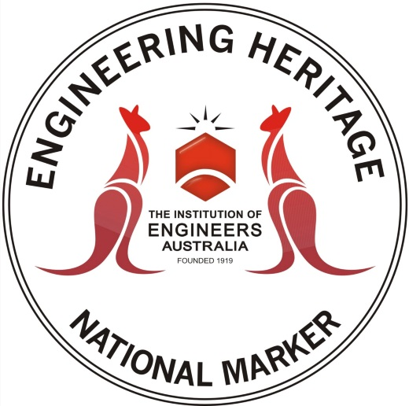

The Story of the INTERSCAN Microwave Landing System

Heritage Recognition Ceremony
Saturday 9 November 2013

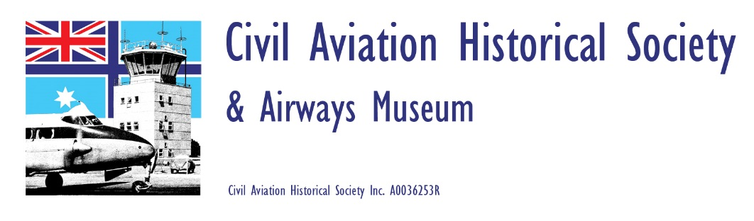

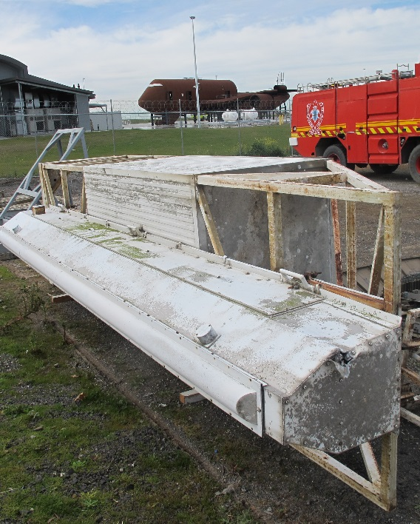

An INTERSCAN antenna recently recovered from Tullamarine Airport for restoration by the Airways Museum prior to placing it on permanent public display. Image: Roger Meyer

The Story of INTERSCAN

The Australian-designed INTERSCAN system was at the forefront of the development of Microwave Landing Systems in the 1970s. The technology was jointly developed by the Department of Transport, CSIRO, AWA, Hawker de Havilland, and the University of Sydney.
INTERSCAN, (which is short for Time INTERval SCANning) Microwave Landing System (MLS) was developed in response to a request from the International Civil Aviation Organisation (ICAO) to find a replacement for the Instrument Landing System (ILS). ILS technology is still in used in most of the world’s commercial airports.
The INTERSCAN system, through superior design and technological diplomacy, was accepted as the world standard technology for the assisted landing of commercial aircraft in 1978. The system is now installed in some major world airports such as London Heathrow. It is also used in military operations and has guided the Space Shuttles into safe landings.
Engineering Heritage Australia has recognised the significance of the INTERSCAN Microwave Landing System with an Engineering Heritage National Marker which will be unveiled on 9 November 2013.

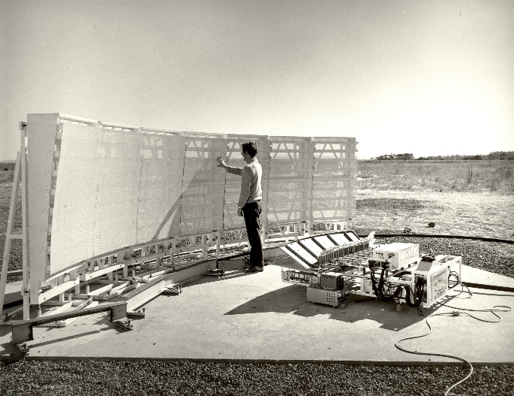

Work being performed on one of the Azimuth Antennas

Image: Civil Aviation Historical Society collection.

The Significance of INTERSCAN

The historical significance of this system is due to the evolution of aircraft landing systems made possible through INTERSCAN’s construction and the advancements made in Australia’s ability to use diplomacy to further its technological agenda.

The basis for the INTERSCAN landing system was the Time Reference Scanning Beam (TRSB) system, a US technology which was claimed at the time to be superior to other scanning beam methods. The technology was dropped by the US, however, due to the lack of a suitable antenna. In short order the CSIRO, Department of Transport and AWA Ltd were able to design and create a system using this superior method. A prototype was built at Tullamarine Airport and used to demonstrate the effectiveness of the technology. This led to its acceptance as the preferred system of the US over four other competing designs.
Several tests were performed in the US using modified Australian/US equipment until it was agreed by the US that all the essential components of the INTERSCAN system would be incorporated into the TRSB system and the two system proposals were merged into one proposal to the ICAO. INTERSCAN was assessed against proposals from several of the world’s most technologically advanced nations such as the UK, France and Germany. The member states selected INTERSCAN as the civil aviation’s world standard for landing systems to replace the older, less capable ILS.

INTERSCAN and MLS Systems Today
INTERSCAN was at the forefront of the development of Microwave Landing Systems. Australia never took up the wide-spread installation of INTERSCAN. However, other international aerospace companies do manufacture systems based on the principles of INTERSCAN.
Engineering Heritage Victoria recently wrote: “As you read these words a handful of airliners may be making their approaches to the crowded twin runways of London’s Heathrow International Airport in near-zero visibility conditions using a Microwave Landing System (MLS) to guide them to a perfect touchdown.
“Simultaneously, a lumbering US Air Force C-130 Hercules freighter is negotiating potential enemy ground fire on its tortuous approach to one of the dangerous airfields of Afghanistan, also guided by an MLS.”
It has been said that Australian flying conditions were not conducive to the widespread adoption of INTERSCAN - the terrain around most of our airports is largely flat and not challenging for manual or automatic landing; our climate is largely mild from an aviation perspective and our pilots do not have to face the risk of enemy ground fire as they make their final approaches.

Engineers & Scientists associated with INTERSCAN
Many people in a number of organisations were involved in the development of INTERSCAN. EHV has selected three as the most influential participants in the project in its nomination document. By good chance there is a photograph of the three in the archives, reproduced below.

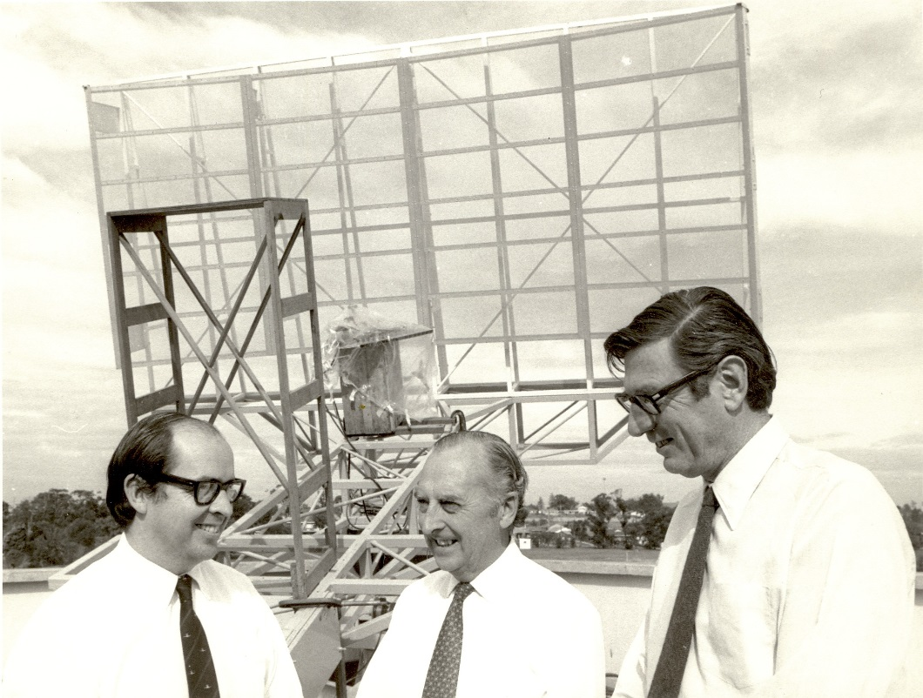

Brian O'Keeffe, left, of the then Department of Civil Aviation, Harry Minnett, centre, CSIRO and Paul Wild, right, CSIRO, in front of the microwave landing system they helped to develop. This file photograph was taken in the early days of INTERSCAN, April, 1973, at the CSIRO Division of Radiophysics at Epping, Sydney.
Image: Civil Aviation Historical Society collection

Dr. John Paul Wild (1923 - 2008)
Paul had an early love of mathematics that he attributed to the enthusiasm and encouragement of his school mathematics teachers. He went to Cambridge University in 1942 and studied mathematics and physics before joining the navy in July 1943. This two year period was to be his only period of university study.
Paul served as a radar officer on the flagship HMS King George V in the British Pacific Fleet for two and a half years.

In 1947, he obtained a job at the Radiophysics Laboratory of Australia’s Council for Scientific and Industrial Research (CSIR) and moved to Sydney. A year later he joined Joe Pawsey’s Radioastronomy Group.

In 1971, Paul took over from E. G. (“Taffy”) Bowen as chief of CSIRO’s Division of Radiophysics. While continuing his interest in solar studies, he also looked for opportunities to use the skills gained from the radioastronomy work and to provide a balance of pure and applied work in the division. Discussions with the Department of Civil Aviation identified a replacement for the existing commercial aircraft all-weather Instrument Landing System as a key opportunity, which was taken up with great enthusiasm by Paul. This work led to the INTERSCAN Microwave Landing System.

Paul was awarded the Royal Medal of the Royal Society in 1980, “In recognition of his conception of the basic principles of the INTERSCAN instrument landing system and the guidance of its development to a successful conclusion.”

Paul was appointed chairman and chief executive of CSIRO in 1978. As chairman of CSIRO (1978 to 1985), he was Australia’s national science leader. He led the organisation through a restructuring to modernise it and bring it closer to the industries and community it serves. Recognising that CSIRO needed to adapt and provide scientific and technological leadership in a changing world, he wrote in 1984, “Yet, whatever the changes, one characteristic must remain inviolate: a high standard of excellence and originality. Without excellence and originality, research achieves nothing.”

Harry Clive Minnett (1917-2003)
Harry Minnett was born at Hurstville in Sydney on 12 June 1917.

He studied science and engineering at the University of Sydney, where the Professor of Electrical Engineering was the far-seeing JPV Madsen. Harry graduated in Science (Mathematics and Physics) in 1939 and in Engineering (Mechanical and Electrical) with First-Class Honours in 1940.
In April 1940, Harry Minnett joined the Council for Scientific and Industrial Research (CSIR, renamed CSIRO in May 1949), soon after the establishment of the Radiophysics Laboratory for research into advanced radar systems. He remained with the organisation until his retirement in 1981.
In 1972, Paul Wild appointed Harry as Engineering Director for the INTERSCAN MLS project. The pair had complementary expertise and both had enthusiasm.
Harry's role as Engineering Director continued through the feasibility studies in 1972, and during the design definition phase in 1973 when the Australian company AWA was awarded a contract from the Department of Transport to engineer and manufacture a system for flight trials at Tullamarine Airport, Melbourne.
Harry's antenna expertise was called on particularly for the conceptual and design phases. One of the antennas was an electronically scanned Torus Reflector. He wrote: “The vertical profile of an azimuth reflector was shaped by synthesis techniques to produce a very sharp cut-off along the ground and an optimum shape at other vertical angles”. The technology developed for the new surface of the Parkes radio telescope was directly applicable to all the reflector antennas for INTERSCAN.
In September 1978, Harry was appointed Chief of the Division of Radiophysics for a period of three years.

Adjunct Professor Brian O'Keeffe AO ( - )
Adjunct Professor Brian O'Keeffe Hon LLD (Monash), BE (Qld), FIE Aust, FAIN, FSAA, can rightly be described as one of the giants of Departmental history, having played a major part in making Australia's reputation for excellence in aviation on the world stage.
Brian O'Keeffe graduated as Bachelor of Engineering (Electrical) from the University of Queensland in 1956 and joined the Department of Civil Aviation (DCA) where he was engaged in the design and supervision of radio installations and special electronic investigations. From 1957 to 1959 he carried out Navigation Aids research at the University of Adelaide under sponsorship from DCA.
He took a leading role in the international development of the MLS, writing the first paper presented to ICAO in 1967 proposing that the ILS be replaced and was then involved actively in the development of what came to be known as MLS. He was responsible for the then Department of Transport's (the successor organisation to DCA) MLS program, which, together with other research and manufacturing bodies in Australia, produced and tested a complete MLS for presentation to ICAO. He promoted the benefit of international collaboration and eventually a combined multi-State proposal was put to ICAO using essentially the Australian signal format. Thus, the Time Reference Scanning Beam system was adopted by ICAO as the international standard in 1978.

In 1984, he became the Australian member and then Chairman of the ICAO Special Committee on Future Air Navigation Systems (FANS).
Brian O'Keeffe left Airservices Australia in 1997 and is presently the Managing Director of FANS PLANS P/L where he provides high level advice on the planning and implementation of the new CNS/ATM System as developed by the Future Air Navigation Systems (FANS) Committee of the International Civil Aviation Organisation (ICAO). In 2004 ICAO bestowed on him their highest award, the Edward Warner award, only the third awarded to an Australian. He is also Adjunct Professor in Engineering at the University of Canberra.

An Introduction to MLS

Microwave Landing Systems (MLS) provide precise navigation guidance necessary for the exact alignment and descent of aircraft. MLS are capable of being used to perform approach and landings down to zero visibility conditions.
The MLS system consists of several pieces of ground-based equipment with the standard configuration including:
- An Azimuth Station: This station provides the landing aircraft with azimuth navigation guidance as well as data communications to the aircraft which can include 3D locations of the MLS equipment, waypoint coordinates, ground equipment performance levels, DME status, runway conditions and weather conditions.
- Back Azimuth Station: This station provides the aircraft with guidance for missed approaches and departures.
- An Elevation Station: This station provides the aircraft with the approach elevation angle.
- DME/P (Precision Distance Measuring Equipment): this piece of equipment provides range guidance. The accuracy of the DME equipment is improved when paired with MLS installations; to account for the accuracy of the azimuth and elevation stations, the accuracy of the systems range information is around 30m.
As the name suggests guidance information is provided to the aircraft in the microwave frequency range, operating between 5031 and 5091 MHz with 200 possible channels. Both the azimuth station and the elevation station share a single frequency with angle and data functions time shared. The DME/P operates on a different frequency band of 962 to 1105 MHz but each DME/P channel is paired with one of the 200 microwave channels for consistency.

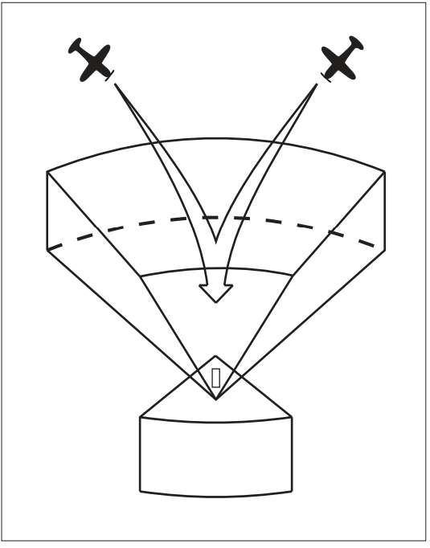
3D Volume Representation

In its standard configuration the MLS provides a landing window of 40 degrees on each side of the runway centreline and 15 degrees above the runway; the range of the equipment extends 37 km along the landing path.
When pairing all of the information from the various stations the system is able to accurately identify the aircraft’s position in 3D space. This allows the system to provide standard landing guidance to MLS- equipped aircraft. Other benefits of the system include curved or segmented landing approach paths and selectable glide paths.
Combining 200 separate channels, higher than the foreseeable requirements of any airport and having low susceptibility to interference from weather conditions, airport ground traffic and other environmental factors, the MLS is a highly robust and accurate landing system that has been described by the FAA as “precision three−dimensional navigation guidance accurate enough for all approach and landing manoeuvres”.

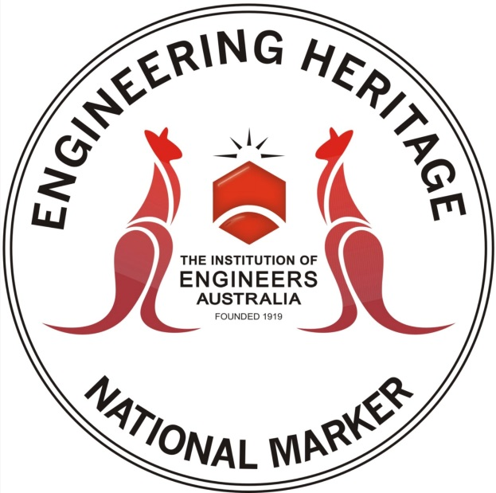

This document has been prepared as a handout for the ceremony to recognise the INTERSCAN Microwave Landing System under the Engineering Heritage Australia, Heritage Recognition Program.

Prepared by Engineering Heritage Victoria.

The ceremony was arranged by Engineering Heritage Victoria in association with the Civil Aviation Historical Society and Airways Museum.

November 2013.

Attachment 6 – EA Media Release

Global aircraft safe-landing system recognised by engineering heritage award

Engineers Australia will recognise the Interscan Microwave Landing System – a highly technical safe-guard system designed to help aircraft land safely in hazardous conditions – for its engineering significance at a heritage recognition ceremony to be held on Saturday 9 November.

“Engineers Australia’s Victorian Heritage Group will award the Interscan Microwave Landing System with an Engineering Heritage National Marker for its high-end engineering technology which revolutionised global aircraft landing,” said Owen Peake, Chair of Engineering Heritage Victoria.

“The Interscan Microwave Landing System installation at Melbourne International Airport was used as a prototype in March 1975 to conduct a demonstration of its operation for the International Civil Aviation Organization. In 1978, through superior design and technological diplomacy, the system was accepted as the world standard technology for assisted landings.

“Microwave Landing Systems are used today in specialist applications such as aiding aircraft on their approaches to land at crowded airports like Heathrow International Airport in near-zero visibility, to lumbering US Air Force C-130 Hercules freighters approaching dangerous airfields in Afghanistan.

“The precision, safety and security behind the Interscan Microwave Landing System was world-class, and reinforces Australian engineering as a leader in global aviation safety.

“The Engineering Heritage National Marker recognises the historic significance of Interscan. The superior engineering behind the Interscan Microwave Landing System is just one example of Australia’s leadership in aviation technology on a world scale,” Mr Peake said.

Event date: Saturday 9 November 2013
Time: 9.45am for 10am sharp - 10.30am
Venue: INTERSCAN, Microwave Landing System, The Airways Museum, Essendon Airport Victoria 3040

Directions: The Airways Museum is at the rear of Building 44, Wirraway Road, Essendon Airport.
Enter via Vaughan Street and Edgar Johnston Lane off Wirraway Road.

For more information please visit: www.engineersaustralia.org.au/events/interscan

–ENDS–

Media Contact:
Sara Ross – National Media Manager Engineers Australia
Phone: (02) 6270 6565 | mobile: 0402 419 962 | sross@engineersaustralia.org.au
Follow us on Twitter: #EngAustralia
Attachment 7 – EHA Magazine Article

INTERSCAN - a great Australian invention

Engineering Heritage Victoria conducted a heritage recognition ceremony for the INTERSCAN system at the Airways Museum, Essendon Airport in Melbourne on 9 November 2013. The Airways Museum already had an INTERSCAN exhibit and the addition of the National Engineering Marker to this exhibit raises the profile of INTERSCAN with visitors to the museum.
The Marker was unveiled by National Councillor Madeleine McManus representing Engineers Australia, Professor Brian O’Keeffe AO, previously of Department of Civil Aviation and involved in INTERSCAN and Roger Meyer OAM, President of the Civil Aviation Historical Society.
INTERSCAN was an early Microwave Landing System (MLS), invented in Australia, which became the International Civil Aviation Organisation (ICAO) world standard for high precision landing systems to replace the older Instrument Landing System (ILS). The development work on INTERSCAN was complex with Department of Transport, CSIRO, AWA Limited, Hawker de Havilland and University of Sydney all involved. Australia teamed up with the United States to submit INTERSCAN to ICAO which adopted the system as the world standard in 1978.
Thirty five years later the old ILS is still in use in many parts of the world and many countries have moved to Global Position System (GPS)-based automatic landing systems. However, for the most challenging applications MLS remains the preferred solution. In recent times British Airways chose MLS for Heathrow Airport in London. Their objective was to be able to continue landing in poor visibility conditions, quite common at Heathrow, and hence avoid disruption of their passengers when the airport was closed to other users not equipped with MLS. The United States Air Force adopted MLS, using portable ground-based equipment, for use at the most dangerous forward military airfields, such as those in Afghanistan. Their objective is to achieve more flexible approaches to airfields where enemy ground fire represents a particular risk. The USAF has equipped its C-130 (Hercules) and C-17 (Globemaster III) transports with MLS equipment.
A MLS system was also used by NASA to land the Space Shuttle fleet.
Many people who had been involved in the development of INTERSCAN attended the ceremony which created a strong reminder of the ground-breaking Australian INTERSCAN technology and the high profile which Australia has had in the past and continues to strive for in air navigation aids.
The nomination for the heritage recognition was written by two Victoria University engineering students, Johnathon Schembri and Anthony Slattery under the Work Experience Project which has been running between Victoria University and Victoria Division for several years. Eight students are taking part in this project in the 2013/2014 university Summer Break, writing nominations for four more fascinating Victorian sites.
The prototype INTERSCAN equipment was installed on the east-west runway at the Tullamarine Airport although it has not been in use for many years. In 2013 it was removed for restoration and future display, at a publicly accessible area at Tullamarine.
The Airways Museum at Essendon is a fascinating collection telling the story of air traffic control, navigation aids and civil aviation communications systems with a strong emphasis on Australian technologies. Any engineer with the slightest interest in this area will find the museum a treasure trove. Go and have a look at it.
EHV has a strong link with the Airways Museum and it is very likely that we will team with them again in the future as they have access to a great deal of technology of engineering heritage significance.
Owen Peake
Chair
Engineering Heritage Victoria

CAPTIONS FOR IMAGES

1 National Councillor Madeleine McManus speaking at the unveiling of the Engineering Heritage Recognition National Marker for the INTERSCAN Microwave Landing System. Image: Owen Peake

PHOTO ID: 009.Interscan Ceremony.Madeleine McManus Speaking.Nov 2013

2. INTERSCAN Experimental Azimuth antenna during the early development phase in the 1970s. Image: Civil Aviation Historical Society Collection.

PHOTO ID: INTERSCAN.Azimuth Prototype

3. The key scientists involved in the development of INTERSCAN: Brian O’Keeffe, left, and Harry Minnett, centre, of Department of Civil Aviation with Dr Paul Wild, right, of CSIRO in front of an early INTERSCAN antenna at the CSIRO Division of Radiophysics at Epping, Sydney. Image: Civil Aviation Historical Society Collection.

PHOTO ID: INTERSCAN.Scientists Involved.Epping.1973

4. United States Air Force C-130 Hercules of Air Mobility Command, Pope Field, North Carolina, equipped with MLS equipment. Image: United States Air Force.

PHOTO ID: C-130 Hercules.USAF

Attachment 8 - EA Magazine Article

INTERSCAN recognised - a great Australian invention

INTERSCAN was an early Microwave Landing System (MLS), invented in Australia, which became the International Civil Aviation Organisation (ICAO) world standard for high precision landing systems to replace the older Instrument Landing System (ILS). The development work on INTERSCAN was complex with Department of Transport, CSIRO, AWA Limited, Hawker de Havilland and University of Sydney all involved. Australia teamed up with the United States to submit INTERSCAN to ICAO which adopted the system as the world standard in 1978.
Thirty five years later ILS is still in use in many parts of the world and many countries have moved to Global Position System (GPS)-based automatic landing systems. However, for the most challenging applications MLS remains the preferred solution. In recent times British Airways chose MLS for Heathrow Airport in London. Their objective was to be able to continue landing in poor visibility conditions, quite common at Heathrow, and hence avoid disruption of their passengers when the airport was closed to other users not equipped with MLS. The United States Air Force adopted MLS, using portable ground-based equipment, for use at the most dangerous forward military airfields, such as those in Afghanistan. Their objective was to achieve more flexible approaches to airfields where enemy ground fire represents a particular risk. The USAF has equipped its C-130 (Hercules) and C-17 (Globemaster III) transports with MLS equipment.
Engineering Heritage Victoria conducted a heritage recognition ceremony for the INTERSCAN system at the Airways Museum, Essendon Airport in Melbourne on 9 November 2013. The Airways Museum already had an INTERSCAN exhibit and the addition of the National Engineering Marker to this exhibit raises the profile of INTERSCAN with visitors to the museum.
The Marker was unveiled by National Councillor Madeleine McManus representing Engineers Australia, Professor Brian O’Keeffe AO, previously of Department of Civil Aviation and involved in INTERSCAN and Roger Meyer OAM, President of the Civil Aviation Historical Society.
Many people who had been involved in the development of INTERSCAN attended the ceremony which created a strong reminder of the ground-breaking Australian INTERSCAN technology and the high profile which Australia has had in the past and continues to strive for in air navigation aids.
The nomination for the heritage recognition was written by two Victoria University engineering students, Johnathon Schembri and Anthony Slattery under the Work Experience Project which has been running between Victoria University and Victoria Division for several years. No less than 10 students are expected to take part in this project t in the 2013/2014 university Summer Break.
The prototype INTERSCAN equipment, installed on the east-west runway at the Tullamarine Airport, had been left in place but no longer in use until earlier this year when it was removed for restoration and future display at Tullamarine.

Owen Peake
Engineering Heritage Victoria

CAPTIONS FOR IMAGES

1. National Councillor Madeleine McManus speaking at the unveiling of the Engineering Heritage Recognition National Marker for the INTERSCAN Microwave Landing System. Image: Owen Peake.
2. Roger Meyer, Brian O’Keeffe and Madeleine McManus after unveiling the INTERSCAN marker. Image: Owen Peake.

Attachment 9 - EV Newsletter Article

INTERSCAN recognised - a great Australian invention

INTERSCAN was an early Microwave Landing System (MLS), invented in Australia, which became the International Civil Aviation Organisation (ICAO) world standard for high precision landing systems to replace the older Instrument Landing System (ILS). The development work on INTERSCAN was complex with Department of Transport, CSIRO, AWA Limited, Hawker de Havilland and University of Sydney all involved. Australia teamed up with the United States to submit INTERSCAN to ICAO which adopted the system as the world standard in 1978.
Thirty five years later ILS is still in use in many parts of the world and many countries have moved to Global Position System (GPS)-based automatic landing systems. However, for the most challenging applications MLS remains the preferred solution. In recent times British Airways chose MLS for Heathrow Airport in London. Their objective was to be able to continue landing in poor visibility conditions, quite common at Heathrow, and hence avoid disruption of their passengers when the airport was closed to other users not equipped with MLS. The United States Air Force adopted MLS, using portable ground-based equipment, for use at the most dangerous forward military airfields, such as those in Afghanistan. Their objective is to achieve more flexible approaches to airfields where enemy ground fire represents a particular risk. The USAF has equipped its C-130 (Hercules) and C-17 (Globemaster III) transports with MLS equipment.
A MLS system was also used by NASA to land the Space Shuttle fleet.
Engineering Heritage Victoria conducted a heritage recognition ceremony for the INTERSCAN system at the Airways Museum, Essendon Airport in Melbourne on 9 November 2013. The Airways Museum already had an INTERSCAN exhibit and the addition of the National Engineering Marker to this exhibit raises the profile of INTERSCAN with visitors to the museum.
The Marker was unveiled by National Councillor Madeleine McManus representing Engineers Australia, Professor Brian O’Keeffe AO, previously of Department of Civil Aviation and involved in INTERSCAN and Roger Meyer OAM, President of the Civil Aviation Historical Society.
Many people who had been involved in the development of INTERSCAN attended the ceremony which created a strong reminder of the ground-breaking Australian INTERSCAN technology and the high profile which Australia has had in the past and continues to strive for in air navigation aids.
The nomination for the heritage recognition was written by two Victoria University engineering students, Johnathon Schembri and Anthony Slattery under the Work Experience Project which has been running between Victoria University and Victoria Division for several years. No less than 10 students are expected to take part in this project t in the 2013/2014 university Summer Break.
The prototype INTERSCAN equipment, installed on the east-west runway at the Tullamarine Airport, had been left in place but no longer in use until earlier this year when it was removed for restoration and future display at Tullamarine.
The Airways Museum at Essendon is a fascinating collection telling the story of air traffic control, navigation aids and civil aviation communications systems with a strong emphasis on Australian technologies. Any engineer with the slightest interest in this area will find the museum a treasure trove. Go and have a look at it.

Owen Peake
Engineering Heritage Victoria

CAPTIONS FOR IMAGES

1 National Councillor Madeleine McManus speaking at the unveiling of the Engineering Heritage Recognition National Marker for the INTERSCAN Microwave Landing System. Image: Owen Peake

2. INTERSCAN Experimental Azimuth antenna during the early development phase in the 1970s. Image: File source unknown.

Attachment 10 - Body of typical thank you letter

See separate Excel Spreadsheet for Mail Merge Addresses

DRAFT 1 (to go on Division President’s Letterhead)

Dear

On behalf of Engineers Australia, Victoria Division and Engineering Heritage Victoria, I would like to thank you for your support of and contribution to the INTERSCAN Heritage Recognition Ceremony on 9 November 2013.
The event was very successful and the marking of the site is an important step to inform present and future generations of Australians of the significant heritage values of Australian engineering.
Events of this nature are valuable to Engineers Australia to inform and inspire the engineering profession about the importance of the heritage of engineering and are equally important to the local communities in which significant engineering heritage sites are located to inform the public and instil a sense of civic and community pride in the achievements of the community.

Yours sincerely

John McIntosh
B.E (Hons), B.Bus, FIEAust, CPEng, EngExec, NPER, MAICD
Division President
Engineers Australia
Victoria Division

11 November 2013

Report prepared by:

OWEN PEAKE
Secretary
Engineering Heritage Victoria
4 Islington Street
COLLINGWOOD VIC 3066
Phone: 03 9419 0820
Email: owen.peake@bigpond.com

12 March 2015

CHANGE CONTROL
VERSION 1 12 March 2015 Based on Shell Document. Initial drafting.

Taken from the interpretation panel to be unveiled on 9 November 2013.
Engineering Heritage Victoria, Nomination for Heritage Recognition, INTERSCAN, Version 7, 8 Sept 2013, page 18.
These systems were based on beam technology and Doppler technology.
A US-developed system.
From the web flyer for the INTERSCAN Heritage Recognition Ceremony, written by Engineering Heritage Victoria Chair, Owen Peake.
Engineering Heritage Victoria, Nomination for Heritage Recognition, INTERSCAN, Version 7, 8 Sept 2013, page 32. Extracts only used.
Thomas BM, Robinson BJ, 2005, Biographical memoirs: Harry Clive Minnett 1917-2003, Australian Academy of Science. Extracts only used.
The Civil Aviation Historical Society, www.airwaysmuseum.com, downloaded 8 Sept 2013. Extracts only used.
Engineering Heritage Victoria, Nomination for Heritage Recognition, INTERSCAN, Version 7, 8 Sept 2013, page 50.
Horizontal.

